|  |  |
| --- | --- |
| \\VFILERDPI\DPI-Home\OBRIENR2\My Documents\Downloads\PP logo.jpg |  |
| **COUNCIL ASSESSMENT REPORT**  PLANNING PANEL | |

|  |  |
| --- | --- |
| PANEL REFERENCE & DA NUMBER | PPSSEC-288 - MOD/2023/0247 |
| PROPOSAL | Section 4.55(2) application to modify Determination DA/2022/0033 dated 5 September 2022 to reconfigure the internal layout and external windows and doors of the grandstand and broadcasters building including amendments to reflect NCC/BCA requirements, alter the external finishes, amend conditions relating to tree management and other minor changes. |
| ADDRESS | Henson Park, Centennial Street MARRICKVILLE NSW 2204 |
| APPLICANT | Mrs Kristy Hodgkinson |
| OWNER | Inner West Council |
| LODGEMENT DATE | 14 February 2022 |
| APPLICATION TYPE | Section 4.55(2) - Modification of consent |
| REGIONALLY SIGNIFICANT CRITERIA | Clause 3, Schedule 6 of *State Environmental Planning Policy (Planning Systems) 2021* : Development has a capital investment value of more than $5 million and Inner West Council is the owner of the land. |
| CIV | $9,646,438 (excluding GST) |
| KEY SEPP/LEP | * *State Environmental Planning Policy (Planning Systems) 2021;* * *Inner West Local Environmental Plan 2022* |
| TOTAL & UNIQUE SUBMISSIONS KEY ISSUES IN SUBMISSIONS | Nil |
| DOCUMENTS SUBMITTED FOR CONSIDERATION | * Council’s Assessment Report * Architectural Plans * Civil Drawings |
| SPECIAL INFRASTRUCTURE CONTRIBUTIONS (S7.24) | N/A |
| RECOMMENDATION | Approval |
| DRAFT CONDITIONS TO APPLICANT | N/A |
| SCHEDULED MEETING DATE | 23 November 2023 |
| PLAN VERSION | 30 October 2023 Issue 4 |
| PREPARED BY | Crawford Architects |
| DATE OF REPORT | 14 November 2023 |

**EXECUTIVE SUMMARY**

DA/2022/0033 “*To demolish part of the premises and carry out alterations and additions to the existing grandstand and associated building to provide additional site facilities and construct a new broadcaster building on the site*” was approved by the Sydney Eastern City Planning Panel on 5 September 2022. The subject (Section 4.55(2)) application to modify a development consent was lodged on 4 August 2023.

The development, as approved and proposed to be modified, is for a ‘recreation facility (major)’, which is a permissible land use with consent in the RE1 zone, the site is located within.

Henson Park is located in Marrickville, with access via Sydenham Road and at the termination of Centennial, Woodland and Amy Street. The site is listed as a local heritage item, a former brickworks. The park was opened in 1933 after the brick pits were drained and infilled. Henson Park is owned and managed by Inner West Council.

Council adopted the Henson Park Plan of Management (POM) and Masterplan on 20 July 2021, which provides a framework for planning and management of the park over the next ten years.

The site contains a grandstand/pavilion and broadcast building on the northern side of the playing field. This is the area of the proposed works, and the remainder of the park is not subject to this application.

In 2017, the Newtown Jets entered into an 8-year agreement with the former Marrickville Council to allow exclusive use for match play for the Newtown Jets and the AFL NSW/ACT until the year 2025. The site is also utilised by the local community for passive and active recreation purposes and dog walking.

The proposed modifications do not result in significant changes to the approved development and there are no substantial concerns with the proposed modifications. Amended plans and additional information were submitted to Council to address concerns regarding impacts to existing trees and vehicular movement behind the grandstand.

There were no concurrence or referral requirements from agencies for the proposal and the application is not integrated development pursuant to Section 4.46 of the *Environmental Planning and Assessment Act 1979* (‘EP&A Act’)*.*

The application was placed on public exhibition from 6 September 2023 and no submissions were received.

The application is referred to the Sydney Eastern City Planning Panel (‘the Panel’) as the development is *regionally significant development* pursuant to Section 2.19(1) as it satisfies the criteria in 3 of Schedule 6 of the Planning Systems SEPP as the proposal is development for development that has a capital investment value of more than $5 million and Council is the owner of the land on which the development is to be carried out. Accordingly, the Sydney Eastern City Planning Panel is the consent authority for the application. The proposal is consistent with this Policy.

A briefing was held with the Chair of the Panel on 24 October 2023 where key issues were discussed, including tree management, vehicular movement and quality of information provided on the submitted plans.

The key issues associated with the proposal included:

1. *Tree Management* – Proposed deletion of conditions and impact on existing trees.
2. *Vehicular movement* – Insufficient clearance for vehicles to pass behind the grandstand.

Following consideration of the matters for consideration under Section 4.55(2) and Section 4.15(1) of the *Environmental Planning and Assessment Act 1979* (*EP and A Act 1979*), the provisions of the relevant State Environmental Planning Policies, and the applicable Development Control Plan, the proposal is considered supportable.

Subject to recommended conditions, the proposed modifications will not result in any adverse environmental impacts and is considered to be in the public interest.

It is recommended that, subject to amended conditions, the application to modify a consent is approved.

1. **THE SITE AND LOCALITY**
   1. **The Site**

* Henson Park (the site) is located in Marrickville, with access via Sydenham Road and at the termination of Centennial, Woodland and Amy Street (Figures 1 and 2).
* The site of a former brickworks, the park was opened in 1933 after the brick pits were drained and infilled. Henson Park is owned and managed by Inner West Council (Council).
* Henson Park is zoned for public recreation and is defined as community land. Council adopted the Henson Park Plan of Management (POM) and Masterplan on 20 July 2021, which provides a framework for planning and management of the park over the next ten years. The POM was subject to public consultation with the local community.
* The site is legally described as Lot 423 in Deposited Plan 1035319. It has a total area of 48,699m2.
* The site contains a grandstand/pavilion and broadcast building (Figures 3-6) on the northern side of the playing field. This is the area of the proposed works, and the remainder of the park (Figure 7) is not subject to this application.
* In 2017, the Newtown Jets entered into an 8-year agreement with the former Marrickville Council to allow exclusive use for match play for the Newtown Jets and the AFL NSW/ACT until the year 2025.
* Henson Park hosts up to 20 ticketed games for each sporting code per winter and summer season and other ticketed events are held throughout the year.
* The site is also utilised by the local community for passive and active recreation purposes and dog walking. There is an off-leash dog walking area located to the south of the playing field (refer to Figures 5 to 9).
* Henson Park is listed as a Local Heritage Item under Schedule 5 of *IWLEP 2022* (I1217) being a former brick pit and for its longstanding sporting use.

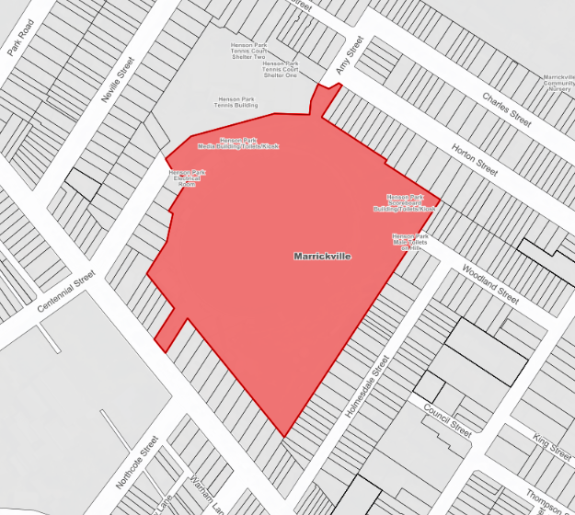

Figure 1: Location Plan 1

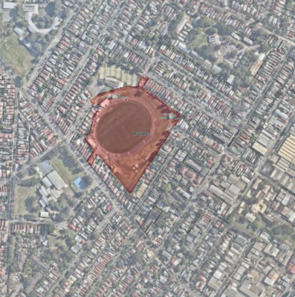

Figure 2: Location Plan 2

Figure 3: Existing Grandstand

Figure 4: Existing broadcast building

Figure 5: Existing stadium and broadcast building viewed from the playing field

Public access between Centennial Street and Amy Street

Figure 6: View showing the "Charlie Meader Memorial Gates", providing entry from Centennial Street and tennis club to the north

Figure 7: View to the southern side of the playing field and the dog walking area

**The Locality**

To the north of the grandstand is the Marrickville District Hard Court Tennis Club on a separate parcel of land accessed via Centennial Street, and the Amy Street playground accessed via Amy Street.

Henson Park is surrounded by low density residential development and adjoins dwelling houses along the southern, western, eastern, and north-eastern boundaries.

**Plan of Management and Masterplan**

The Plan of Management and Masterplan is a guiding framework, which directs the future vision, planning, management and use of the park. The formulation of the POM was subject to community consultation and was adopted on 20 July 2021.

The Master Plan component is a design report outlining the actions required for improvement, intended to guide the physical upgrade of the site over the next ten years. An extract of the draft Masterplan in the POM is shown in Figure 8.

The POM includes upgrade works to the existing grandstand to provide a better spectator experience, improved access, reconfiguration of the back of house and service area facilities and improved storage and club facilities, including a gymnasium. The modified proposal is consistent with the POM.

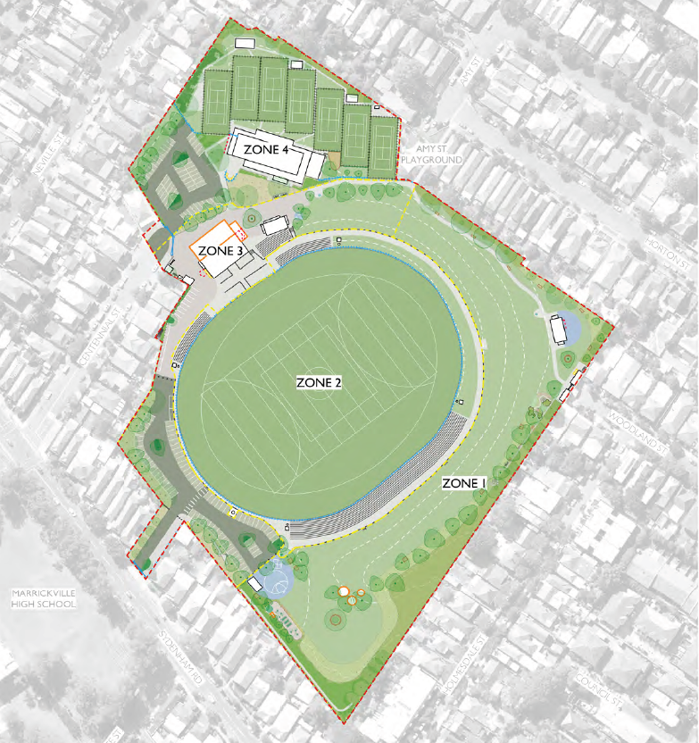

Figure 8: Henson Park Masterplan

1. **THE PROPOSAL AND BACKGROUND** 
   1. **The Proposal**

The following modifications are proposed:

*Grandstand*

* Internal layout changes at the basement level for change rooms, utility areas and first aid
* Modifications to incorporate building services
* Relocation of rainwater and on site detention tanks
* Addition of a ventilation plenum at the basement
* Changes to the wet areas at the ground floor
* Modification to Stair 2 from basement to Level 2
* Modification to Ramp 1, including a ceiling above
* Introduction of service risers
* Modification to the position of windows and louvres as well as extent in certain locations
* Increased height of the grandstand by 844mm
* Modification to the external material from off-form concrete and Lysaght longline 305 to CFC cladding
* Increase the size of the balcony by 7.3sqm
* Reducing the size of the gym
* Replacement of the vertical sunshades with horizontal louvres
* Modification to Stair 2 roof line
* Enclosure of the lobby, including ceiling
* Inclusion of a condenser platform
* Adjustment to the position of the building by 250mm to accommodate existing footings
* Additional signage
* Revisions to external door types and sizes

*Multipurpose Building*

* Addition of the lift pit to the basement
* Adjustments to canteen benching
* Addition of building services
* Adjustment to lift size for AS1428 compliance
* Addition of fire rated walls
* Additional acoustic measures, including side glazing
* Additional information relating to fire services
* Addition of a condenser platform to the roof
* Removal of the upper deck (74.63m2) including roof cover (50.52m2) and replacement with a platform (23.38m2) and simple cover over (18.03m2)
* Removal of lift to the roof top level and rework of the angular roof profile
* Removal of photovoltaic panels
* Revisions to external door types and sizes
* Revisions to the extent of windows and louvres
* Changes to the vertical sunshades
* Increased height of the building by 820mm and a minor increase to the height of the roof over by 120mm
* Adjustment to the wall finish from off form concrete to CFC cladding
* Adjustment to the position of the building by 250mm to accommodate existing footings
* Additional doors to service areas

*Ground Floor External Modifications*

* Changes to paving extent to provide a vehicular traffic route, including trafficable subgrade
* Introduction of bollards to ensure that vehicles do not enter into the adjacent pedestrian space
* Adjustments to ramp thresholds

In addition, it is sought to delete two conditions concerned with mitigating impact to existing trees imposed on the DA consent.

* 1. **Background**

DA/2022/0033 “To demolish part of the premises and carry out alterations and additions to the existing grandstand and associated building to provide additional site facilities and construct a new broadcaster building on the site” was approved by the Sydney Eastern City Planning Panel on 5 September 2022.

The Section 4.55(2) application to modify a development consent was lodged on 4 August 2023. A chronology of this application since lodgement is outlined below including the Panel’s involvement (briefings) with the application:

**Table 2: Chronology of the DA**

|  |  |
| --- | --- |
| **Date** | **Event** |
| 4 August 2023 | DA lodged |
| 6 September 2023 | Exhibition of the application |
| 26 September 2023 | Community Consultation Session held via MS Teams |
| 19 October 2023 | Request for additional information from Council to applicant |
| 24 October 2023 | Preliminary Panel briefing |
| 25 October 2023 | Civil drawings provided by applicant |
| 26 October 2023 | Council met with the applicant to discuss the request for additional information |
| 31 October 2023 | Amended plans submitted to Council via email, dated 30 October 2023. |
| 14 November 2023 | The amended architectural and civil drawings were submitted via the NSW Planning Portal and accepted by Council under Cl 38(1) of the *Environmental Planning and Assessment Regulation 2021* (‘2021 EP&A Regulation’). |

The amended architectural drawings submitted only included one change. The initially submitted plans depicted that the previously approved, and minimum required, distance for vehicular movement of 3.1 metres between the additions to the grandstand and the fence behind (along the north-western) was reduced to 2.95 metres. The amended plans depict that the fence is to be shifted to provide the required 3.1 metre clearance. In addition, the amended architectural drawings provide a key/comparison of approved and proposed plan numbers and revisions, which was requested as the elevations submitted with the subject application “split up” the two buildings (i.e., the grandstand and multipurpose building) whereas the approved elevations show (an overlay where applicable) both buildings.

The civil drawings submitted depict the proposed relocation of on-site detention tanks.

**STATUTORY CONSIDERATIONS**

When considering a Modification of consent application under Section 4.55(2) of the E*nvironmental Planning and Assessment Act 1979* (‘EP&A Act’), the consent authority must take into consideration the following matters:

*A consent authority may, on application being made by the applicant or any other person entitled to act on a consent granted by the consent authority and subject to and in accordance with the regulations, modify the consent if—*

*(a)  it is satisfied that the development to which the consent as modified relates is substantially the same development as the development for which consent was originally granted and before that consent as originally granted was modified (if at all), and*

*(b)  it has consulted with the relevant Minister, public authority or approval body (within the meaning of Division 4.8) in respect of a condition imposed as a requirement of a concurrence to the consent or in accordance with the general terms of an approval proposed to be granted by the approval body and that Minister, authority or body has not, within 21 days after being consulted, objected to the modification of that consent, and*

*(c)  it has notified the application in accordance with—*

*(i)  the regulations, if the regulations so require, or*

*(ii)  a development control plan, if the consent authority is a council that has made a development control plan that requires the notification or advertising of applications for modification of a development consent, and*

*(d)  it has considered any submissions made concerning the proposed modification within the period prescribed by the regulations or provided by the development control plan, as the case may be.*

In addition, in accordance with section 4.55(3) of the EP&A Act,

*In determining an application for modification of a consent under this section, the consent authority must take into consideration such of the matters referred to in section 4.15(1) as are of relevance to the development the subject of the application. The consent authority must also take into consideration the reasons given by the consent authority for the grant of the consent that is sought to be modified.*

In considering the above:

* The essence of the development, as modified, is substantially the same as the original consent;
* The application was notified in accordance with Council’s Community Engagement Strategy;
* No submissions were received;
* As outlined below, the application has been assessed in accordance with Section 4.15 of the EP&A Act;
* The Sydney Eastern City Planning Panel noted in the reasons for the decision:

*The Panel determines to approve the application for the reasons outlined in the independent consultants Assessment Report.*

*The Panel considers the upgrading of Henson Park facilities to be a community benefit and enhancement of facilities for all sporting codes. Furthermore, it is noted that the Park will still be available for the residents of the local community to access.*

The proposed modifications are minor and do not result in significant changes to the development as approved. The development, as proposed to be modified, still upgrades the Henson Park facilities while retaining access for residents and the community.

The following is a summary of the assessment of the application in accordance with Section 4.15 of the EP&A Act, which outlines that the consent authority must take into consideration the matters outlined in this Section. The matters that are of relevance to the application include the following:

1. *the provisions of any environmental planning instrument, proposed instrument, development control plan, planning agreement and the regulations*

*(i)  any environmental planning instrument, and*

*(ii)  any proposed instrument that is or has been the subject of public consultation under this Act and that has been notified to the consent authority (unless the Planning Secretary has notified the consent authority that the making of the proposed instrument has been deferred indefinitely or has not been approved), and*

*(iii)  any development control plan, and*

*(iiia)  any planning agreement that has been entered into under section 7.4, or any draft planning agreement that a developer has offered to enter into under section 7.4, and*

*(iv)  the regulations (to the extent that they prescribe matters for the purposes of this paragraph),*

*that apply to the land to which the development application relates,*

1. *the likely impacts of that development, including environmental impacts on both the natural and built environments, and social and economic impacts in the locality,*
2. *the suitability of the site for the development,*
3. *any submissions made in accordance with this Act or the regulations,*
4. *the public interest.*

These matters are further considered below.

* 1. **Environmental Planning Instruments, proposed instrument, development control plan, planning agreement and the regulations**

The relevant environmental planning instruments, proposed instruments, development control plans, planning agreements and the matters for consideration under the Regulation are considered below.

* **Section 4.15(1)(a)(i) - Provisions of Environmental Planning Instruments**

The following Environmental Planning Instruments are relevant to this application:

* [*State Environmental Planning Policy (Planning Systems) 2021*](https://legislation.nsw.gov.au/view/html/inforce/current/epi-2021-0724)
* [*State Environmental Planning Policy (Resilience and Hazards) 2021*](https://legislation.nsw.gov.au/view/html/inforce/current/epi-2021-0730)

A summary of the key matters for consideration arising from these State Environmental Planning Policies are outlined in **Table 3** and considered in more detail below.

**Table 3: Summary of Applicable Environmental Planning Instruments**

|  |  |  |
| --- | --- | --- |
| **EPI** | **Matters for Consideration** | **Comply (Y/N)** |
| State Environmental Planning Policy (Planning Systems) 2021 | Chapter 2: State and Regional Development   * Section 2.19(1) declares the proposal regionally significant development pursuant to Clause 3 of Schedule 6 as it comprises development that has a capital investment value of more than $5 million and Council is the owner of the land on which the development is to be carried out. | Y |
| SEPP (Resilience & Hazards) | Chapter 4: Remediation of Land   * Section 4.6 - Contamination and remediation has been considered during the assessment of the DA. Subject to conditions imposed on the DA consent, which will remain in force, the proposal is satisfactory. | Y |
| State Environmental Planning Policy (Transport and Infrastructure) 2021 | Chapter 2: Infrastructure   * Section 2.48(2) (Determination of development applications—other development) – electricity transmission - the proposal is satisfactory, subject to conditions. * Section 2.118(2) - Development with frontage to classified road | Y |
| Inner West Local Environmental Plan 2022 | * Clause 1.2 – Aims of Plan * Clause 2.3 – Permissibility and zone objectives * Clause 2.7 – Demolition * Clause 5.10 – Heritage conservation * Clause 6.1 – Acid sulfate soils * Clause 6.2 – Earthworks * Clause 6.3 – Stormwater management * Clause 6.8 – Development in areas subject to aircraft noise | Y |

Consideration of the relevant SEPPs is outlined below:

[*State Environmental Planning Policy (Planning Systems) 2021*](https://legislation.nsw.gov.au/view/html/inforce/current/epi-2021-0724) *(‘*Planning Systems SEPP’)

Chapter 2: State and Regional Development

The proposal is *regionally significant development* pursuant to Section 2.19(1) as it satisfies the criteria in 3 of Schedule 6 of the Planning Systems SEPP as the proposal is development for development that has a capital investment value of more than $5 million and Council is the owner of the land on which the development is to be carried out. Accordingly, the Sydney Eastern City Planning Panel is the consent authority for the application. The proposal is consistent with this Policy.

*State Environmental Planning Policy (Resilience and Hazards) 2021*

The site is located at Henson Park, Centennial Street Marrickville and, therefore, the *State Environmental Planning Policy (Resilience and Hazards) 2021* is relevant to the development application.

Chapter 4: Remediation of Land

The provisions of Chapter 4 of *State Environmental Planning Policy (Resilience and Hazards) 2021 (‘the* Resilience and Hazards SEPP’) were considered in the assessment of the development application. The proposed modifications have no implications and, as such, the proposal, subject to conditions imposed on the DA consent remaining in force, will be suitable for the proposed community facility and is consistent with this SEPP.

[*State Environmental Planning Policy (Transport and Infrastructure) 2021*](https://legislation.nsw.gov.au/view/html/inforce/current/epi-2021-0732)

Chapter 2 Infrastructure

*Development likely to affect an electricity transmission or distribution network*

The proposed modifications have no impact on the substation and switchboard building located adjacent to the Centennial Street entry of the site. Conditions imposed on the DA consent include requirements to protect Ausgrid assets.

*Development with frontage to classified road*

Vehicular access to the land is provided from Sydenham Road, which is a Classified Road. However, no changes are proposed to the existing, and approved, vehicular access arrangements.

*Inner West Local Environmental Plan 2022*

The relevant local environmental plan applying to the site is the *Inner West Local* *Local Environmental Plan 2022* (‘the LEP’). The aims of the LEP are:

*(aa) to protect and promote the use and development of land for arts and cultural activity, including music and other performance arts,*

*(a)  to encourage development that demonstrates efficient and sustainable use of energy and resources in accordance with ecologically sustainable development principles,*

*(b)  to conserve and maintain the natural, built and cultural heritage of Inner West,*

*(c)  to reduce community risk from and improve resilience to urban and natural hazards,*

*(d)  to encourage walking, cycling and use of public transport through appropriate intensification of development densities surrounding transport nodes,*

*(e)  to facilitate economic growth and employment opportunities within Inner West,*

*(f)  to encourage diversity in housing to meet the needs of, and enhance amenity for, Inner West residents,*

*(g)  to create a high quality urban place through the application of design excellence in all elements of the built environment and public domain,*

*(h)  to prevent adverse social, economic and environmental impacts on the local character of Inner West,*

*(i)  to prevent adverse social, economic and environmental impacts, including cumulative impacts.*

The proposal is consistent with the aims as the proposal:

* The proposal conserves and maintains the cultural heritage of the Inner West;
* The proposal facilitates economic growth and provides additional employment opportunities in the Inner West;
* The proposed design is of high quality and improves the appearance of Henson Park and the surrounding area;
* The proposal will not result in adverse social, economic or environmental impacts, providing improvements to community facilities within Henson Park.

*Zoning and Permissibility (Part 2)*

The site is located within the RE1 Zone pursuant to Clause 2.2 of the LEP (Figure 9).

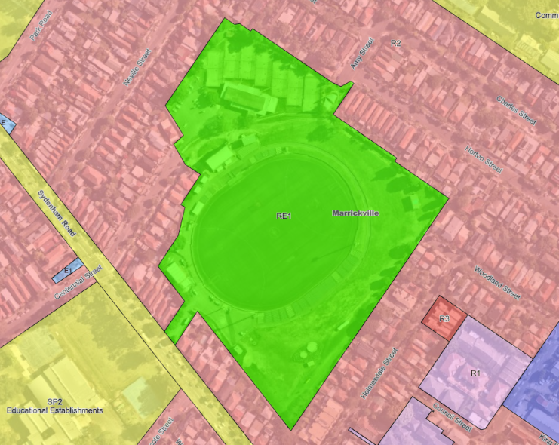

Figure 9: Zoning map

The proposal satisfies the definition of a ‘recreation facility (major)’, which is a permissible use with consent in the Land Use Table in Clause 2.3.

The zone objectives are as follows (pursuant to the Land Use Table in Clause 2.3):

* *To enable land to be used for public open space or recreational purposes.*
* *To provide a range of recreational settings and activities and compatible land uses.*
* *To protect and enhance the natural environment for recreational purposes.*
* *To conserve, maintain and enhance biodiversity and the natural environment, including terrestrial, aquatic and riparian habitats and natural land forms.*

The proposal is considered to be consistent with these zone objectives for the following reasons:

* The site is, and will continue to be, open to the public and can be used for recreational purposes;
* The site provides for various recreational uses and activities, such as sport and walking;
* The proposal will not result in changes to the natural environment;
* The proposal will not result in adverse impacts to flora or fauna on, and adjacent to, the site.

*General Controls and Development Standards (Part 2, 5 and 6)*

The LEP also contains controls relating to miscellaneous provisions and local provisions (no development standards apply to the site). The controls relevant to the proposal are considered in **Table 4** below.

**Table 4: Consideration of the LEP Controls**

|  |  |  |  |
| --- | --- | --- | --- |
| **Control** | **Requirement** | **Proposal** | **Comply** |
| Demolition (Cl 2.7) | The demolition of a building or work may be carried out only with development consent. | Consent for demolition works granted under the DA. No additional demolition works proposed. | Yes |
| Heritage  (Cl 5.10) | * To conserve the environmental heritage of Inner West, * To conserve the heritage significance of heritage items and heritage conservation areas, including associated fabric, settings and views, * To conserve archaeological sites, * To conserve Aboriginal objects and Aboriginal places of heritage significance. | Henson Park is listed as a Local Heritage Item under Schedule 5 of IWLEP 2022(I1217), being a former brickpit. The significance of the place is a function of its past use and the way in which the topography is a manifestation of its genesis from a brickworks to a sporting field, and its associations with sporting use, particularly as the home ground of the Newtown Jets Rugby League Club since the 1930s.  Consideration of the above has been included in the assessment and consent of the DA and, subject to conditions, the heritage significance of the site has been adequately addressed.  The form and scale of the proposal, as approved and proposed to be modified, is considered sympathetic and complimentary to the existing building.  The proposed modifications to the design are almost entirely confined to the new works and the revised proposal does not have a greater heritage impact than the approved development.  The proposed signage is attached to the new addition and is acceptable as it will not detract from the heritage significance of the existing grandstand.  Given the above, the proposal complies with the provisions of Clause 5.10 of IWLEP 2022. | Yes |
| Acid sulphate soils  (Cl 6.1) | To ensure that development does not disturb, expose or drain acid sulfate soils and cause environmental damage. | The site contains Class 3 and 5 Acid Sulfate Soils (Figure 10); however, proposed works are located within the area identified containing Class 5 ASS.  No works are proposed below 5m Australian Height Datum, and the proposed excavation works, are unlikely to lower the water table. | Yes |
| Earthworks (Cl 6.2) | To ensure earthworks for which development consent is required will not have a detrimental impact on environmental functions and processes, neighbouring uses, cultural or heritage items or features of the surrounding land. | No additional earthworks proposed. | Yes |
| Stormwater Management (Cl 6.3) | To minimise impacts of urban stormwater on  (a)  land to which this clause applies, and  (b)  adjoining properties, and  (c)  native bushland, and  (d)  receiving waters. | It is sought to relocate on-site detention tank and rainwater tanks.  Amended stormwater drainage design plans were submitted, which have been reviewed by Council’s development engineer who raised no objections.  The proposed modifications are minor and, subject to adhering to the stormwater drainage design, and conditions imposed on the DA consent, the proposal will remain consistent with this clause. | Yes |
| Development in Areas subject to Aircraft Noise (Cl 6.8) | (a)  to prevent certain noise sensitive developments from being located near the Sydney (Kingsford Smith) Airport and the airport flight paths,  (b)  to assist in minimising the impact of aircraft noise from the airport and the flight paths by requiring appropriate noise attenuation measures in noise sensitive buildings,  (c)  to ensure land use and development near the airport do not hinder or have other adverse impacts on the ongoing, safe and efficient operation of the airport. | An Acoustic Report was submitted with the DA and the proposal, subject to conditions imposed on the DA consent, is capable of satisfying this clause amd will meet the relevant requirements of Table 3.3 (Indoor Design Sound Levels for Determination of Aircraft Noise Reduction) in AS 2021:2015. | Yes |

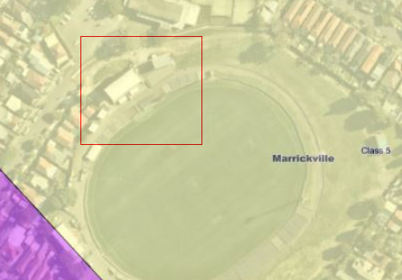

Figure 10: Acid Sulfate Soils map (area of proposed works outlined in red, which are wholly located within Class 5 ASS)

The proposal is considered to be generally consistent with the LEP.

* **Section 4.15(1)(a)(iii) - Provisions of any Development Control Plan**

The following Development Control Plan is relevant to this application:

* *Marrickville Development Control Plan 2011* (‘the DCP’)

The application has been assessed and the following provides a summary of the relevant provisions of the DCP.

| **Part of MDCP 2011** | **Compliance** |
| --- | --- |
| Part 2.1 – Urban Design | Yes |
| Part 2.5 – Equity of Access and Mobility | Yes |
| Part 2.6 – Acoustic and Visual Privacy | Yes |
| Part 2.7 – Solar Access and Overshadowing | Yes |
| Part 2.8 – Social Impact | Yes |
| Part 2.9 – Community Safety | Yes |
| Part 2.10 – Parking | Yes |
| Part 2.11 – Fencing | Yes |
| Part 2.12 – Signs and Advertising | Yes |
| Part 2.16 – Energy Efficiency | Yes |
| Part 2.17 – Water Sensitive Urban Design | Yes |
| Part 2.20 – Tree Management | Yes |
| Part 2.21 – Site Facilities and Waste Management | Yes |
| Part 2.24 – Contaminated Land | Yes |
| Part 2.25 – Stormwater Management | Yes |
| Part 8 – Heritage | Yes |

The following provides discussion of the relevant issues:

Part 2.1 Urban Design

Council’s planning controls do not contemplate development such as sporting facilities and are of limited relevance or applicability to the proposal. Notwithstanding, the urban design principles in the DCP have a role to play in making places that are valued and significant for those who use them.

All development applications that involve substantial external changes that are visible from the public domain are required to be consistent with the urban design principles to ensure a high-quality design outcome for the site. The relevant principles are discussed below:

*Principle 2 – Accessibility*

The proposed development creates, and retains, a connected and accessible concourse that relates to the levels of the surrounding public domain and supports safe, convenient, public circulation through the site. The proposed development will provide improved access for all people and achieve compliance with the *Disability (Access to Premises - Buildings) Standards 2010*.

*Principle 5 – Urban Form*

The changes proposed to the approved built form are minor. The built form, as approved and proposed to be modified, is well-designed and will incorporate high quality materials to create a contemporary expression that is compatible and complementary with the existing structures on site.

Part 2.5 Equity of Access and Mobility

As stated previously, the proposed development will provide improved access for all people and achieves compliance with the *Disability (Access to Premises — Buildings) Standards 2010*. This will be achieved through accessible paths of travel through the main entry and in and around the facility, provision of lift access, accessible sanitary facilities, access to common areas and terraces and stadium seating and accessible car spaces.

Part 2.6 Acoustic and Visual Privacy

The proposed modifications will not result in additional visual or acoustic privacy impacts to surrounding sites and users.

Part 2.7 Solar Access and Overshadowing

The proposed modifications will not result in additional overshadowing.

Part 2.8 Social Impact

The proposed modifications will not result in adverse impacts and the proposal provides significant community benefit in terms of overall site improvements and upgraded sporting facilities.

Part 2.9 Community Safety

The development, as approved and proposed to be modified, is designed having regard to the principles of Crime Prevention through Environmental Design (CPTED) and focuses on the design, planning and structure of the environment.

Part 2.10 Parking

No change proposed to approved traffic and parking provisions/solutions. The amended plans submitted have resolved the initial concern regarding vehicular movement behind the grandstand and proposed multipurpose building.

2.12 Signs and Advertising

The proposal includes two business identification signs to the south-western elevation. The signs are proposed to the rear additions to the grandstand (Figure 11); no signage is proposed to the existing grandstand.

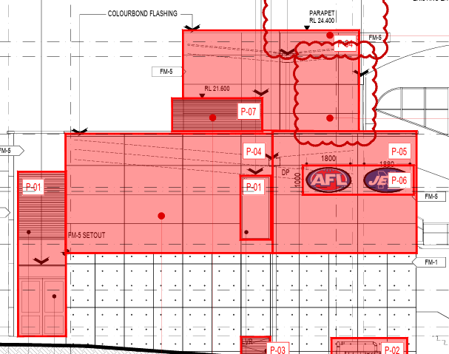

Figure 11: Proposed signage

Control C21 outlines the following:

*Advertising in…RE1 zones will only be permitted:*

1. *Where the applicant shows a justifiable need;*
2. *Where the amenity of the area will not be detrimentally affected; and*
3. *After consideration of the general merits or otherwise of the application.*

The former Marrickville Council, Newtown NRL, Newtown Jets and AFL NSW/ACT entered into an 8-year agreement in 2017 to use Henson Park, which allows exclusive use for match play until the year 2025. The proposed signage is for the approved use and lease, displaying the AFL and Jets logos. The signs are not considered to adversely impact the amenity of the area and will not adversely impact the heritage item. Given that the current lease expires in 2025, it is recommended to impose a condition that ties the signage to the lease (i.e., that the signage must be removed once the lease has expired).

Controls C28 and C29, which relate to signage on heritage items, outline the following:

*C28 Signage strategy for a heritage item*

1. *Any application for a new sign on a heritage item must include a signage strategy that takes into account existing and proposed signs for the building and the policies and recommendations of any conservation management plan; or*
2. *Any sign proposed for a heritage item must be consistent with the recommendations of an approved signage strategy forming part of a development consent or an adopted development plan or conservation management plan applying to the heritage item.*

*C29 All signs on a heritage item must be:*

1. *Consistent in design to the architectural form of the building to which it is attached;*
2. *Of a complementary material, construction and graphics; and*
3. *Appropriately located on the heritage item and of a compatible design and style with appropriate lettering.*

Section 3 of the Henson Park Plan of Management outlines, *inter alia*, purposes for which licensing/leasing will be granted for long-term uses, which includes the following:

*Promotion and advertising including signage in connection with sporting activities or general community use*

The Recommended Management for the heritage item (i.e., Henson Park) outlines the following:

*General maintenance especially to the grandstand.*

As outlined above, the proposed signage is to new additions, not the existing grandstand. As such, the proposal is consistent with C28. The proposed signs are relatively small in size and sympathetic to the architectural form of the building to which they are attached. The signs are of complementary materials, construction and graphics; and are appropriately designed and sited to not result in any adverse impacts to the grandstand, heritage item, nor amenity of surrounding sites and uses.

Control C31 reads as follows:

*Signage illumination*

1. *Internally illuminated signs are not permitted on a heritage item unless they are a reconstruction of an original significant sign or it can be demonstrated that it is an important aspect of the heritage significance of the heritage item.*
2. *Externally illuminated signs are permitted only where:* 
   1. *The design of the sign achieves a high degree of compatibility with the heritage item; and*
   2. *The cabling and conduit supplying power to the sign is completely concealed and does not involve intervention in or damage to significant fabric.*
3. *Flashing or animated signs are not permitted.*

The submitted information does not indicate that the proposed signs are illuminated, flashing, or include animations. To ensure that the proposed signage compliers with this control, it is recommended to impose the following condition:

*The signs to the south-western elevation (labelled P-06) must not be illuminated, flashing, and must not be animated.*

Given the above, subject to recommended conditions, the proposal complies with the relevant controls of this part of the DCP.

Part 2.16 Energy Efficiency Design

The development, as approved and proposed to be modified, incorporates a range of sustainable building principles such as:

* LED lighting;
* smart envelope design;
* inclusion of an energy generation system on site such as solar panels on the roof
* efficient fittings and fixtures; and
* prioritising pedestrian circulation, including exploring ‘valet bike parking’ to assist in game-day peak periods, and other measures to encourage the uptake of sustainable modes of transport.

Part 2.17 Water Sensitive Urban Design

There are no specific provisions that apply to major recreational facilities. Amended civil drawings, designed in accordance with Section 2.25 Stormwater Management of the DCP were submitted. Council’s Development Engineer raises no objection to the proposal, subject to amending conditions imposed on the DA consent as outlined in Attachment A.

Part 2.20 Tree Management

The proposal provides for the retention of all existing street trees.

It is sought to delete conditions 15 and 16 imposed on the DA consent, which were imposed to mitigate impacts on existing trees. Council’s Arborist raised no objections, subject to a new condition being imposed (refer to Attachment A) to ensure that the development will have no adverse impacts on existing trees.

Part 2.21 Site Facilities and Waste Management

A Recycling Waste Management Plan (RWMP), which provides details regarding the likely waste streams generated during the demolition and construction phase and that quantifies anticipated waste volumes and proposed disposal methods, was submitted with the DA and referenced in the notice of determination.

In terms of on-going waste management there will be no change to existing general public and non-match day use. There will also be no change to current match day use and arrangements, other than bump-in provision numbers and the volume of waste receptacles adjusted to suit anticipated crowd sizes. The purpose-built waste management and storage facilities will be designed and sited so as to maximise opportunities for waste avoidance, recycling and re-use within the site.

Part 2.24 Contaminated Land

Refer to Previous discussion under the *Resilience and Hazards SEPP*.

Part 2.25 Stormwater

The proposal includes an On-site Detention Tank (OSD) with water sensitive urban design measures and a series of pits and pipes around the building connecting to the existing network. No objection has been raised by Council’s Development Engineer in relation to stormwater drainage.

Part 8 Heritage

*Refer to the previous discussion under the Clause 5.10 IWLEP 2022.*

* **Section 4.15(1)(a)(iv) - Provisions of Regulations**

Section 61 of the EP&A Regulation 2021 contains matters that must be taken into consideration by a consent authority in determining a development application.

These provisions of the EP&A Regulation 2021 were considered under the DA assessment and were addressed through the imposition of conditions.

The proposed modifications have no implications and, subject to conditions imposed on the DA consent remaining in force, the proposal is consistent with this Section.

* 1. **Section 4.15(1)(b) - Likely Impacts of Development**

The likely impacts of that development, including environmental impacts on both the natural and built environments, and social and economic impacts in the locality must be considered. In this regard, potential impacts related to the proposal have been considered in response to SEPPs, LEP and DCP controls outlined above.

There will be no change to the existing public access between Amy Street and Centennial Street as a result of the proposed modifications. During ticketed events, the side gates to the playing field will be closed, but the existing access for park users between Amy Street and Centennial Street will be retained.

The media space and coaches’ boxes within the broadcast building are required to achieve the modern-day broadcasting technology and specific requirements of the sporting codes.

The proposal does not result in an increase in patron capacity or intensification of the sporting events held on the site. The current cap on the number of ticketed sporting events held each year will not change as a result of the proposed upgrade to the sporting facilities.

Accordingly, it is considered that the proposal will not result in any significant adverse impacts in the locality as outlined above.

* 1. **Section 4.15(1)(c) - Suitability of the site**

Provided that any adverse effects on adjoining properties are minimised, this site is considered suitable to accommodate the proposed modifications, and this has been demonstrated in the assessment of the application.

* 1. **Section 4.15(1)(d) - Public Submissions**

No submissions were received.

* 1. **Section 4.15(1)(e) - Public interest**

The public interest is best served by the consistent application of the requirements of the relevant Environmental Planning Instruments, and by Council ensuring that any adverse effects on the surrounding area and the environment are appropriately managed.

The proposal is in the public interest as it provides improvements to Henson Park and, subject to recommended conditions, the proposal will not result in adverse impacts to the environment.

The proposal is not contrary to the public interest.

1. **REFERRALS AND SUBMISSIONS** 
   1. **Agency Referrals and Concurrence**

N/A

* 1. **Council Officer Referrals**

The development application has been referred to various Council officers for technical review as outlined **Table 6.**

**Table 6: Consideration of Council Referrals**

|  |  |  |
| --- | --- | --- |
| **Officer** | **Comments** | **Resolved** |
| Engineering | Council’s Engineering Officer reviewed the submitted civil drawings and architectural plans and considered that there were no objections, subject to conditions imposed on the DA consent remaining in force. | Yes |
| Urban Forest | Council’s Arborist reviewed the proposal and raised no objections to the proposed deletion of conditions, subject to the addition of a new condition as outlined elsewhere in this report. | Yes |
| Building Surveyor | Council’s Building Surveyor raised no objections. | Yes |
| Heritage | Council’s Heritage Officer/Consultant reviewed the submitted information concluded that the proposed modifications would have no greater impact than the approved development on the heritage item. | Yes |

* 1. **Community Consultation**

The proposal was notified in accordance with the Council’s Community Engagement Strategy from 6 September 2023 until 4 October 2023. The notification included the following:

* A sign placed on the site;
* 868 notification letters sent to adjoining and adjacent properties; and
* Notification on the Council’s website.

Council received no submissions.

1. **CONCLUSION**

This Section 4.55(2) application has been considered in accordance with the requirements of the *EP&A Act* *1979* and the Regulations as outlined in this report. Following a thorough assessment of the relevant planning controls identified in this report, it is considered that, subject to recommended conditions, the application can be supported.

1. **RECOMMENDATION**

That the Sydney Eastern City Planning Panel exercising its functions as the consent authority pursuant to s4.55(2) of the *Environmental Planning and Assessment Act 1979,* grantconsent to application No MOD/2023/0247 which seeks to modify Determination DA/2022/0033 dated 5 September 2022 so as to reconfigure the internal layout and external windows and doors of the grandstand and broadcasters building including amendments to reflect NCC/BCA requirements, alter the external finishes, amend conditions relating to tree management and other minor changes at Henson Park, Centennial Street Marrickville subject to the amendments listed in Attachment A.

The following attachments are provided:

* Attachment A: Draft amended conditions of consent
* Attachment B: Architectural Plans
* Attachment C: Notice of Determination (DA/2022/0033)
* Attachment D: Approved Architectural and Stormwater Plans